**DEPLOYMENT PROCEDURE**

1. Download Sourcetree: <https://www.sourcetreeapp.com/>
2. Each development activity is conceptually linked to a JIRA ticket (User Story).

From the JIRA ticket create a branch

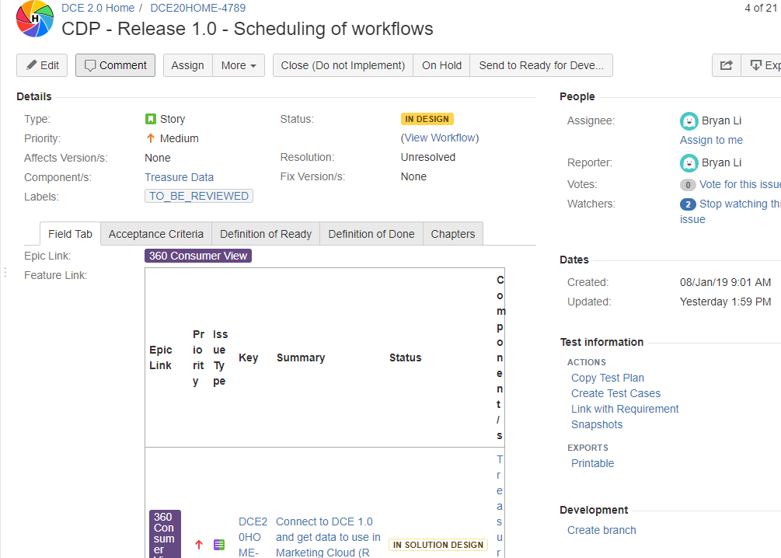

Chose **PMI DCE Bitbcuket**

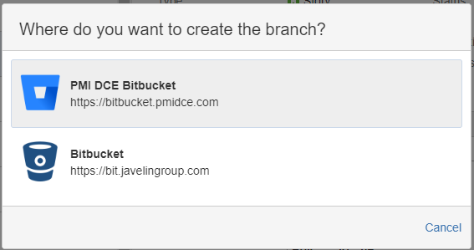

Repository: chose the related repository

Branch Type: Feature

Branch from: develop

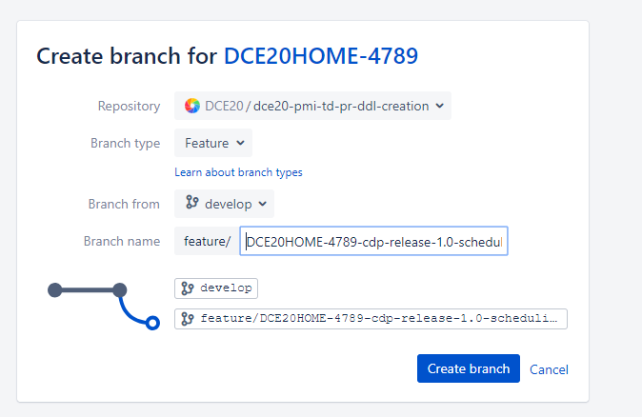

1. Clone the branch in sourcetree

Open the branch create in point 1 and click Clone 🡪 Clone in Sourcetree

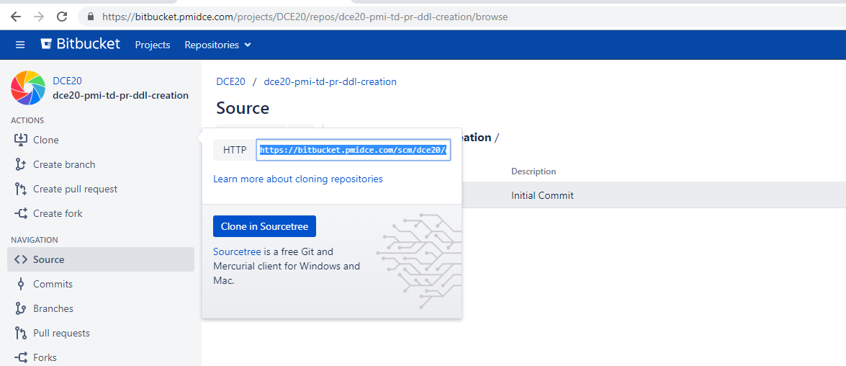

After clicking “Clone in Sourcetree”, Sourcetree app is automatically opened and the below screen is shown.

Press **Clone.**

It is also possible to change the local path in which the branch will be saved

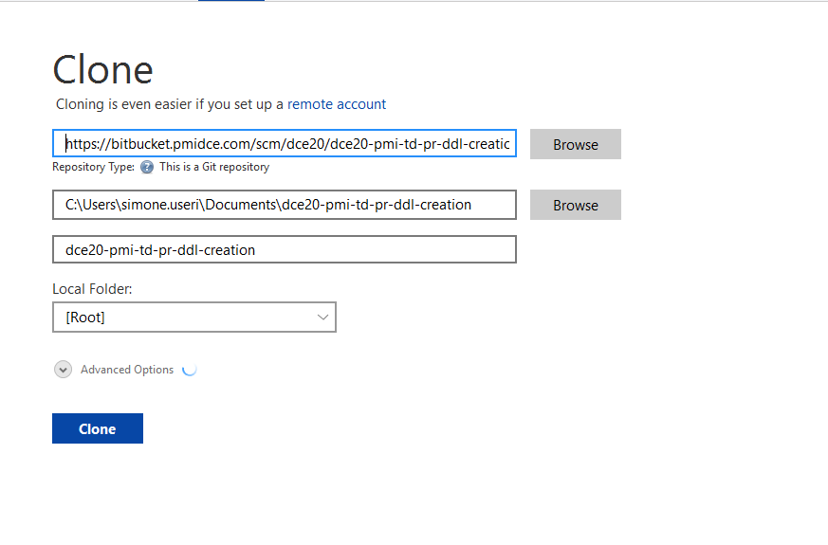

1. Fetch the remote branches

Click Fetch and then press ok

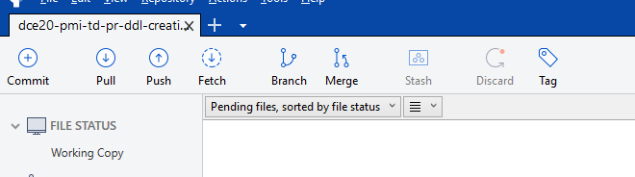

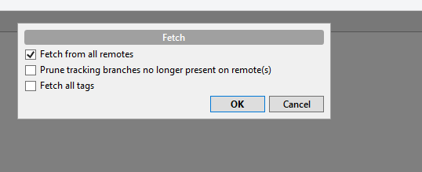

1. Checkout remote branch

In the drop down list at the right go to REMOTES 🡪 feature

Right click on your feature

Press check out

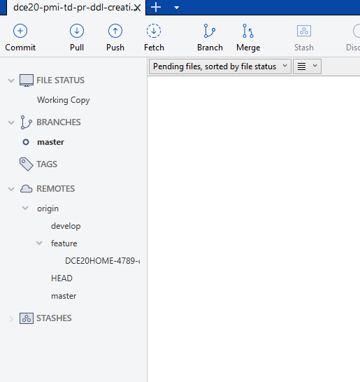

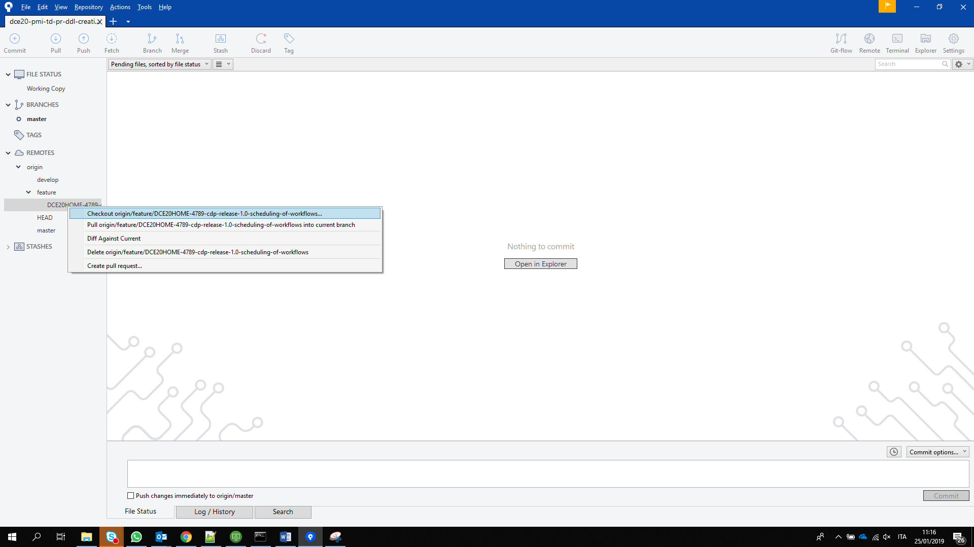

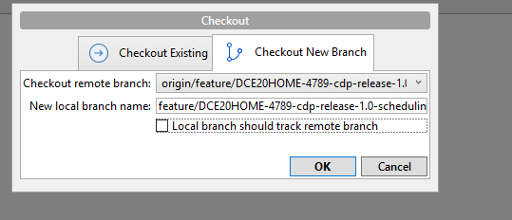

1. Open the branch from your local path and put all the files in .src folder

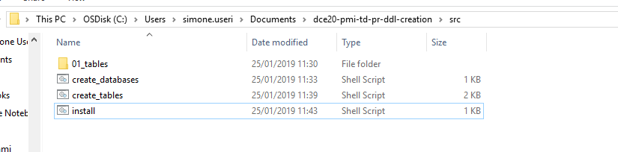

A file install.sh has to be always present. This is the file that the Jenkins job will call for the installation.

Use this repository as template:

<https://bitbucket.pmidce.com/projects/DCE20/repos/dce20-pmi-td-dcs/browse?at=refs%2Fheads%2Fdevelop>

1. Commit changes

After the src folder is completed, go back to Sourcetree. Here you can see all the files that have been changed.

Click “Stage All”

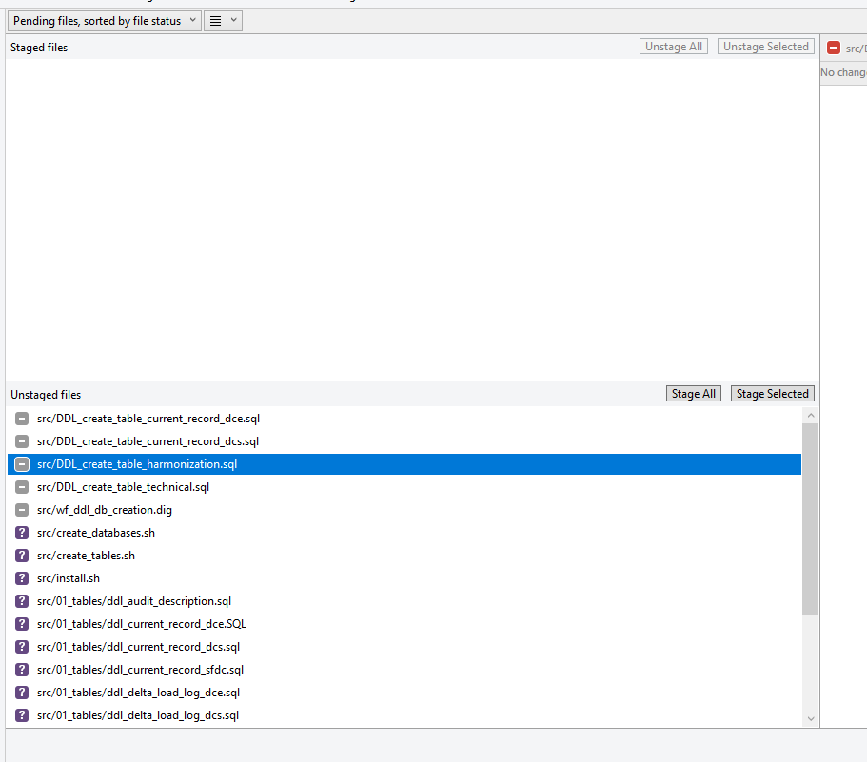

At the bottom of the screen enter the JIRA ticket followed by a description.

Flag “push change immediately”

Press Commit

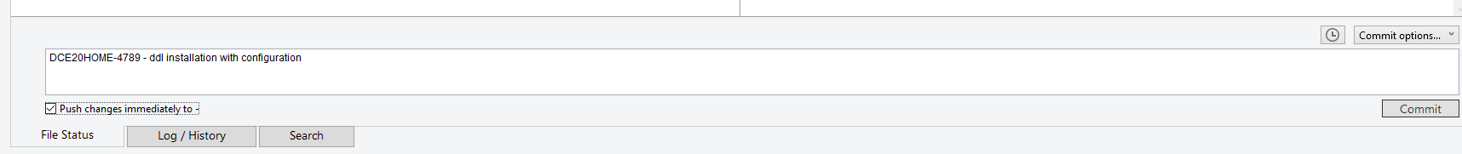

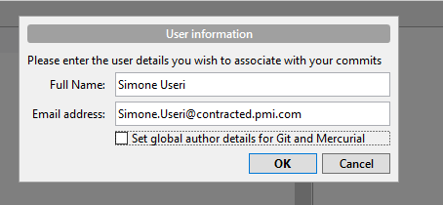Unflag “Set global author details for Git and Mercurial”

Press OK and then Commit

1. Create a pull request

Go back to the branch (in the browser).

Click “Pull Request” and then “Create Pull Request”

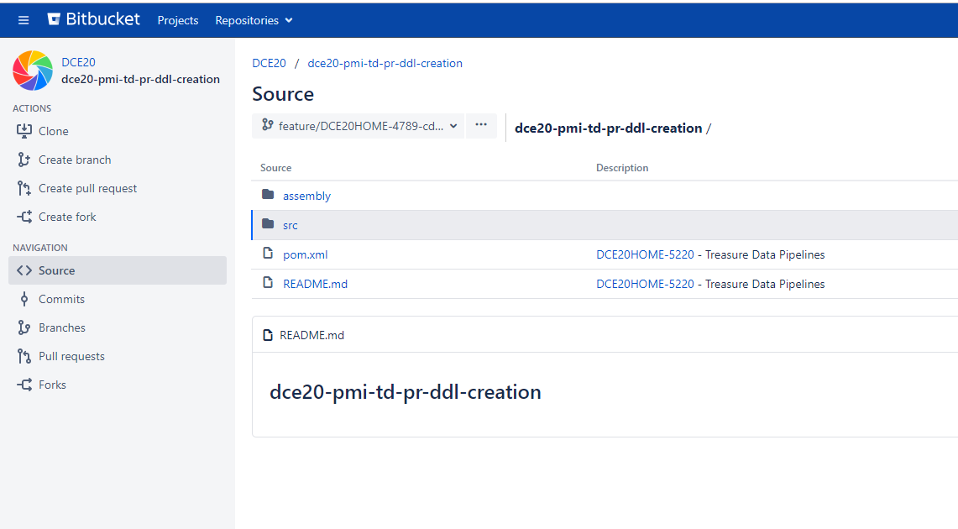

In Source choose the branch that has to me merged

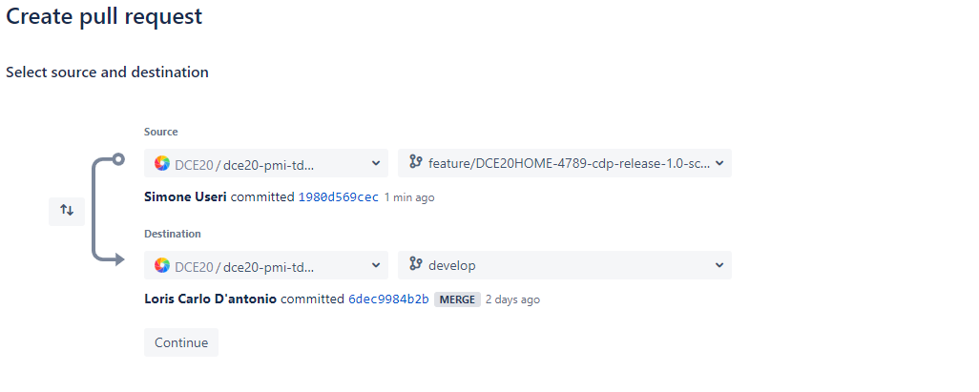In Destination chose always develop

Press Continue

As reviewers put or Bryan Li or Simone Useri

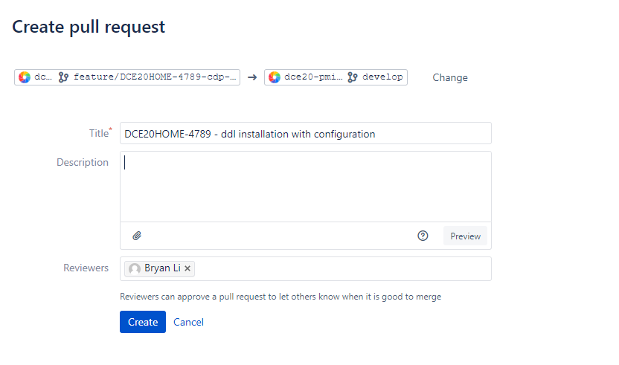 Press Create

1. Merge

After the approval of the reviews the merge button becomes available and you can merge the change.

Flag “delete source branch after merging” (suggested) if you want to delete your branch after the merge.

